617-288-0813

ENTREES
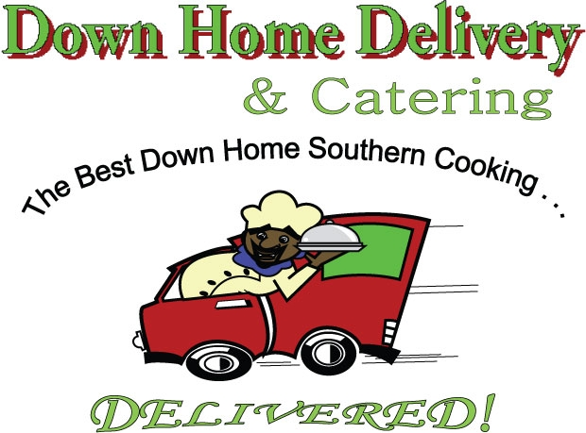

All dinners served with your choice of entree, two side dishes & corn muffin

Consumption of raw or uncooked meat can pose health risk

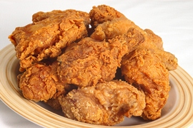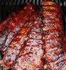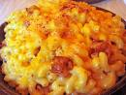
www.downhomedelivery.com

Now Order Down Home

On UberEats & GrubHub Apps!

Dinner Side Sandwich Lil Snack w/Fries
(3 pcs + muffin)
CHICKEN: Jumbo Wings (5 Wings) $17.99 $12.99
Legs & Thighs (2 of each) $16.99 $11.99 $ 9.99
Breasts (2) $16.99 $11.99 $ 9.99
Chicken Tenders $16.99 $11.99 $13.99
Wing Snack (3 Wings
+ Corn Muffin) $ 9.99
Fried ~ BBQ ~ Smothered ~ Baked ~ Sweet Chili ~ Lemon Pepper ~ buffalo
BEEF: Country Pot Roast $17.99 $13.99 $ 9.99
Homemade Meatloaf $15.99 $11.99 $ 8.99
BBQ Boneless Beef Ribs* $20.99 $16.99
BBQ Boneless Beef Rib Snack*
(BBQ Beef Ribs+ Corn Muffin) * $11.99
* Served Fri, Sat, Sun Only

PORK: Southern Fried Pork Chops $18.99 $14.99 $10.99
Savory BBQ Baby Back Ribs $18.99 $14.99
BBQ Rib Snack (3 Ribs +
Corn Muffin) $10.99

FISH: Haddock* $16.99 $12.99 $ 9.99
Catfish* $17.99 $13.99 $ 10.99
Whiting* $14.99 $10.99 $ 8.99
*fried or broiled Served fri, Sat, Sun only
SIDES

$5.99 each/Veggie Plate $13.99

Baked Macaroni & Cheese Sweet Corn Mashed Potatoes Mixed Vegetables
Cabbage* Candied Yams String Beans White Rice
Potatoes & Carrots Collard Greens* French Fries
Black Eyed Peas Potato Salad Hush Puppies** Fried Okra
*items cooked with smoked turkey **Fri, Sat, Sun only

DESSERTS $5.99--$6.99
Sweet Potato Pie Banana Pudding Bread Pudding Lemon Pound Cake
Chocolate Fudge Cake Chocolate Cake Carrot Cake Pineapple Coconut Cake

Corn Muffins $ .75 ea Bottled Water $2.00 ea Other Beverages $2.75 ea

Restaurant Hours: Mon.-Fri. 3pm to 10pm; Sat. 12pm to 10pm; Sun. 12pm to 8pm
$4.00-$7.00 Delivery Charge/$1.00 Credit Card Fee ~ Sales Tax not included ~ All major Credit/Debit Cards Accepted
Let Down Home Cater your next Event – Call Gale at 646-226-0118

Down Home Delivery & Catering ~ 2 Bowdoin St., Dorchester, MA 02124

